

Diptford Art and Design/Design and Technology
Rolling Programme

This rolling programme integrates the art and design/design and technology Kapow scheme which comprehensively covers the KS1 and KS2 art and design/design and technology national curriculum. Our rolling programme provides a cohesive and structured approach to teaching the national curriculum, ensuring that each unit contributes towards achieving all end-of-key-stage attainment targets.

Design and technology national curriculum aims and how it links to our rolling programme

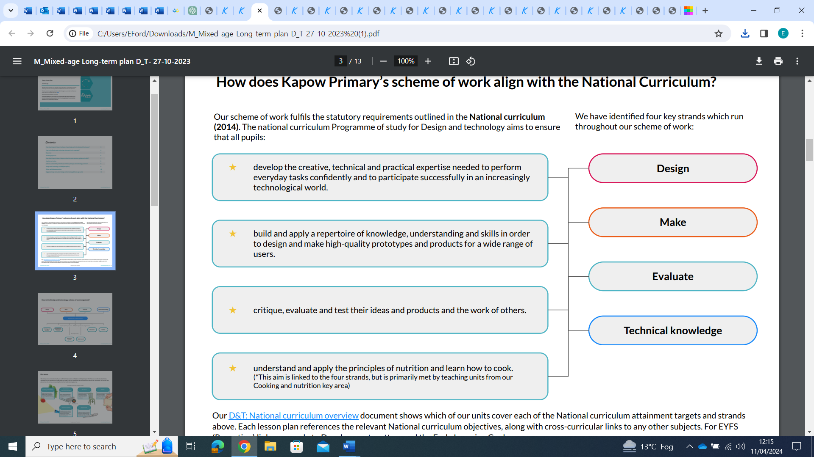
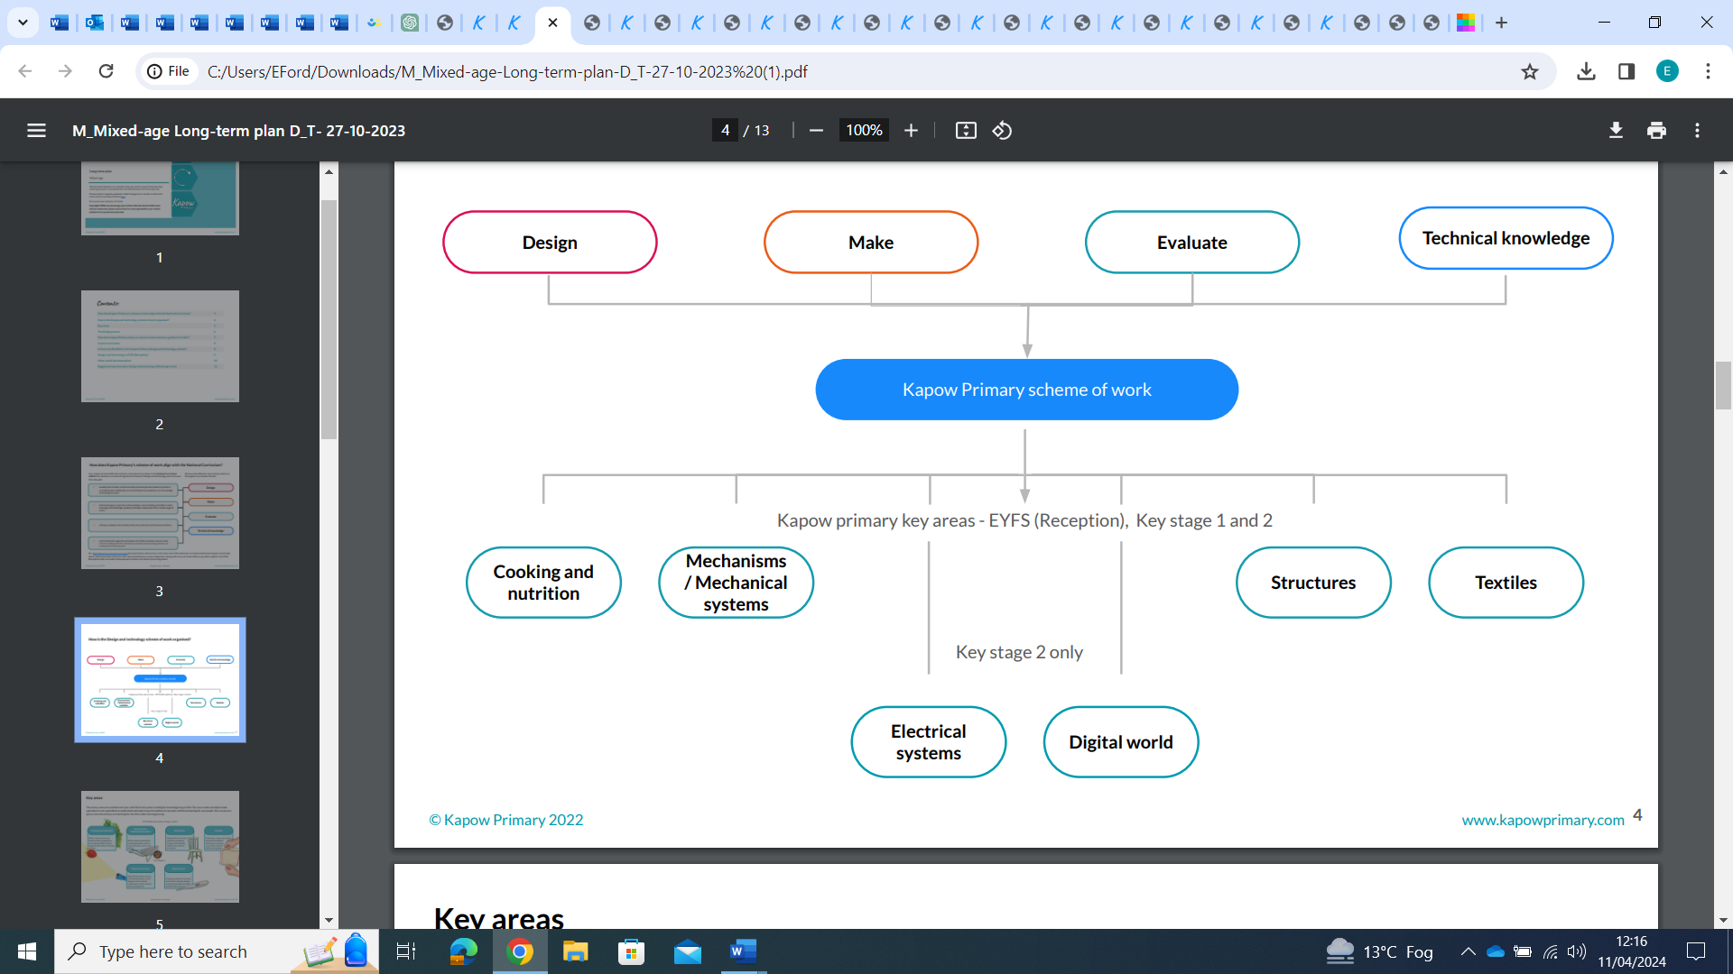

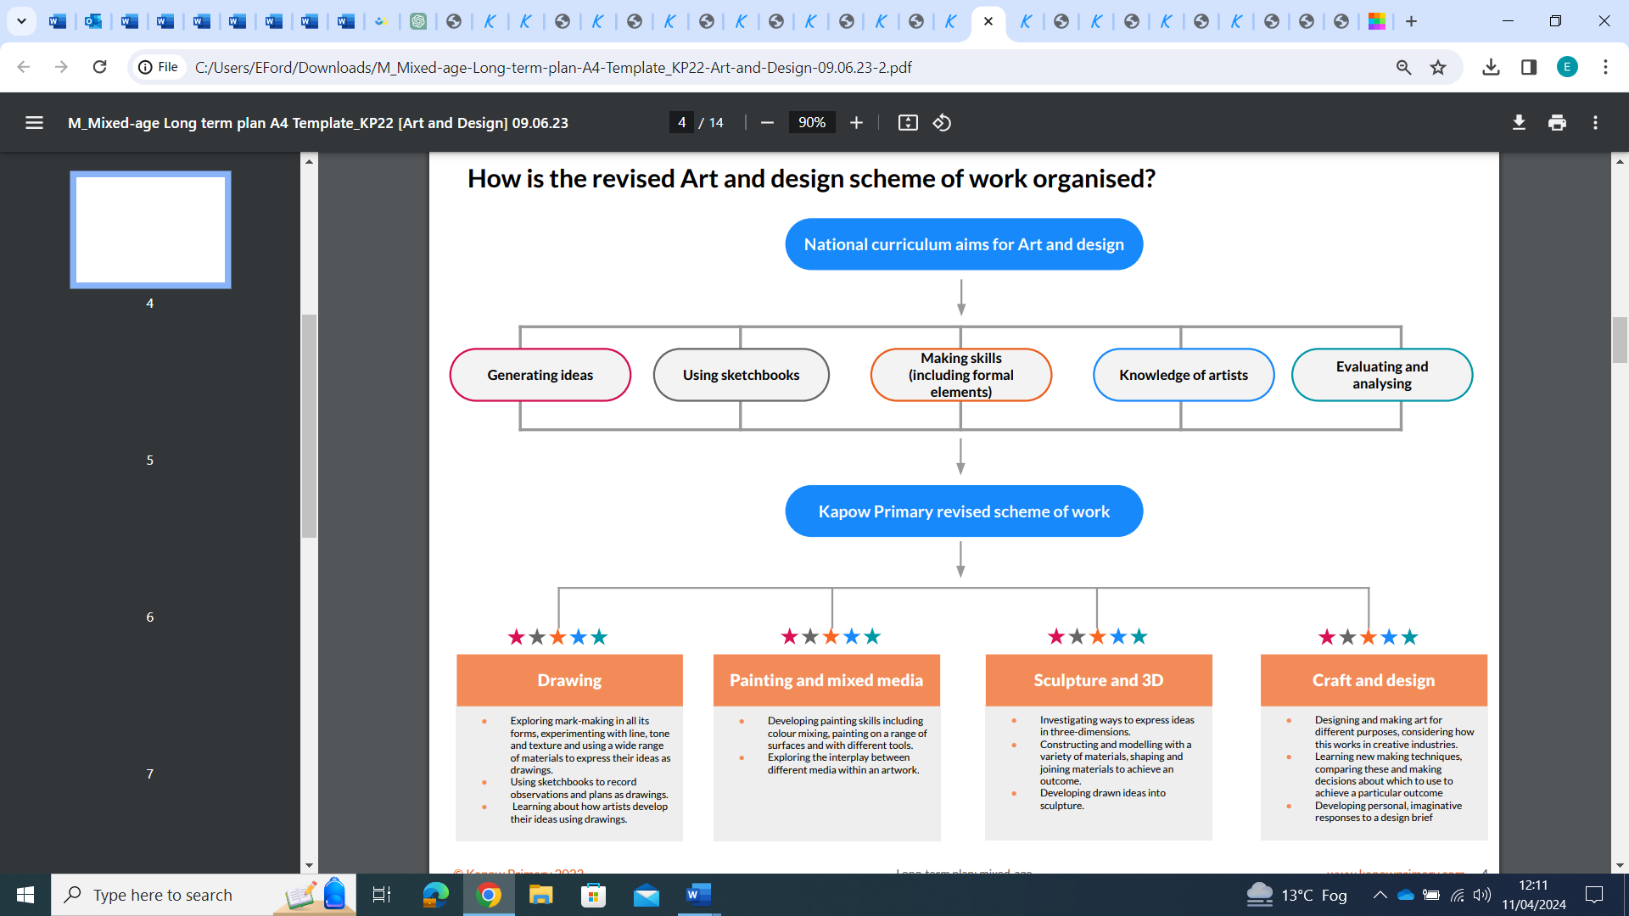
Art and design national curriculum aims and how it links to our rolling programme

Rolling Programme

 | Autumn term |  | Spring term |  | Summer term |  | Stand alone lessons
 | Design and technology | Art and design | Design and technology | Art and design | Design and technology | Art and design
Year 1/2 Cycle A | Structures: Constructing a windmill  (4 lessons) | Drawing: Make your mark  (5 lessons) | Textiles: Puppets (4 lessons) | Sculpture and 3D:  Paper play (5 lessons) | Cooking and nutrition: Smoothies (6 lessons) | Sculpture and 3D:  Clay houses (5 lessons) | Design and technology  Unit: Cooking and nutrition: Balanced diet (Lesson 1)  Art and design  Unit: Drawing: Tell a story (Lesson 2, 4 and /or 5)
Year 1/2 Cycle B | Structures: Baby bear's chair  (4 lessons) | Craft and design:  Map it out (5 lessons) | Mechanisms: Fairground wheel (4 lessons) | Painting and mixed media: Colour splash  (5 lessons) | Mechanisms: Making a moving monster  (4 lessons) | Painting and mixed media: Life in colour  (5 lessons) | Design and technology  Unit: Mechanisms: Making a moving story book  (Lesson 1)  Art and design  Unit: Craft: Woven wonders (Lesson 1, 2 and/or 3)

 | Autumn term |  | Spring term |  | Summer term |  | Stand alone lessons
 | Design and technology | Art and design | Design and technology | Art and design | Design and technology | Art and design
Year 3/4 Cycle A | Digital world: Wearable technology (6 lessons) | Sculpture and 3D: Abstract shape and space (5 Lessons) | Cooking and nutrition: Eating seasonally  (6 lessons) | Drawing: Growing artists  (5 lessons) | Structures: Constructing a castle  (4 lessons) | Drawing: Power prints  (5 lessons) | Design and technology  Unit: Cooking and nutrition: Adapting a recipe  (Lesson 2)  Unit: Textiles: Fastenings (Lesson 1)  Art and design  Unit: Sculpture and 3D: Mega materials (Lesson 1, 2 and/or 5)
Year 3/4 Cycle B | Structure: Pavilions (4 lessons) | Painting and mixed media: Light and dark  (5 lessons) | Mechanical systems: Making a slingshot car  (4 lessons) | Craft and design: Ancient Egyptian scrolls  (5 lessons) | Electrical systems:  Torches  (4 lessons) | Craft and design: Fabric of nature (5 lessons) | Design and technology  Unit: Textiles: Cross-stitch and appliqué (Lesson 1)  Unit: Mechanical systems: Pneumatic toys (Lesson 1 and/or 2)  Art and design  Unit: Painting and mixed media: Prehistoric painting  (Lesson 1, 3 and /or 4)
Year 5/6 Cycle A | Electrical systems:  Doodlers (4 lessons) | Drawing: I need space  (5 lessons) | Mechanical systems: Making a pop-up book  (4 lessons) | Painting and mixed media: Portraits  (5 lessons) | Cooking and nutrition: Developing a recipe  (6 lessons) | Sculpture and 3D: Making memories - (5 lessons) | Art and design  Unit: Craft and design: Architecture (Lesson 3, 4 and/or 5)
Year 5/6 Cycle B | Textiles: Waistcoats (4 lessons) | Sculpture and 3D: Interactive installation  (5 lessons) | Structure: Playgrounds (4 lessons) | Craft and design: Photo opportunity (5 lessons) | Digital world: Navigating the world  (4 lessons) | Drawing: Make my voice heard  (5 lessons) | Art and design  Unit: Painting and mixed media: Artist study  (Lesson 1, 4 and/or 5)

