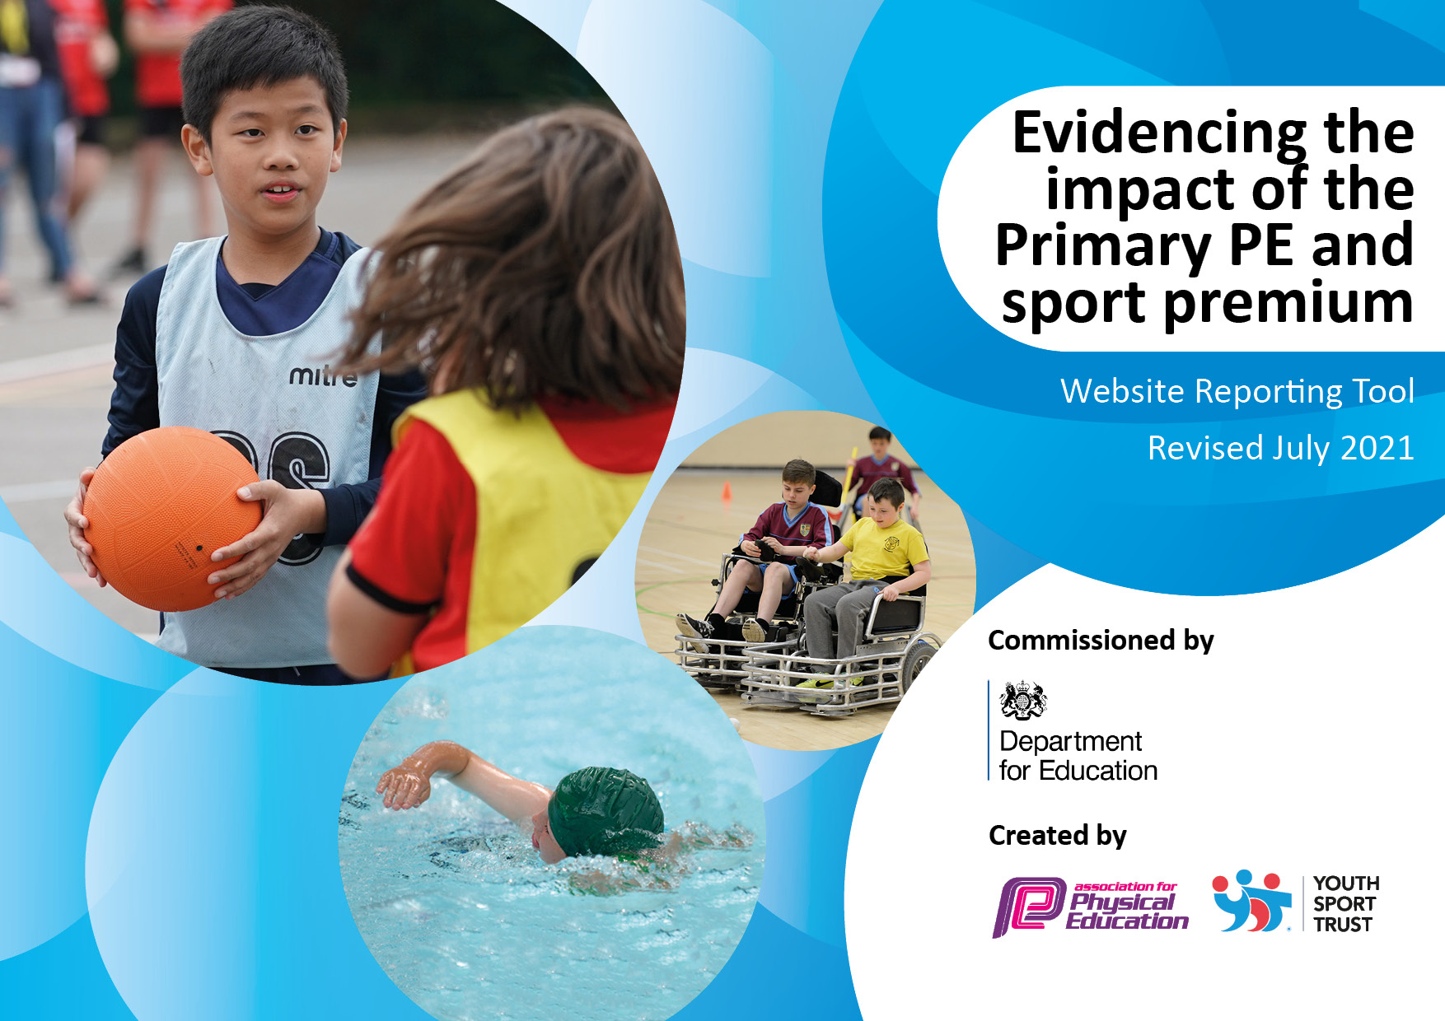

Projected Spending:

All of the amounts in the document below have been agreed with the academy head and relevant member of the PE department.

Action Plan and Budget Tracking
Capture your intended annual spend against the 5 key indicators. Clarify the success criteria and evidence of impact that you intend to measure to evaluate for pupils today and for the future.

Academic Year: 2022/23 | Total fund allocated: 16,580 | Date Updated: 02/03/2022
Key indicator 1: The engagement of all pupils in regular physical activity – Chief Medical Officers guidelines recommend that primary school pupils undertake at least 30 minutes of physical activity a day in school |  |  |  | Percentage of total allocation:
Intent | Implementation |  | Impact
Your school focus should be clear what you want the pupils to know and be able to do and about  what they need to learn and to  consolidate through practice: | Make sure your actions to achieve are linked to your intentions: | Funding allocated: | Evidence of impact: what do pupils now know and what can they now do? What has changed?: | Sustainability and suggested next steps:
Increase daily physical activity by engaging all students in daily active playtimes and during the school day.  Golden Mile programme tracks students running distances over the school year. Classed participate each day to increase their distance and subsequently their physical activity.  Increase PA through extracurricular opportunities for KS1 | Specialist equipment has been purchased so students of all ages have access to a range of different physical activities during these times.  All students participate in the Golden Mile each day for additional physical activity.  We have increased the clubs available to students in KS1. These have been led by external providers as well as class teachers. This year clubs have been:  - Football club  - Gymnastics club  - Multi-sports club  - Frisbee club  - Yoga club | £150  No cost  £0 parent funded |  | Equipment owned by the school so can be used next year and beyond. Lunchtime programme is planned to give greater opportunity for students to be active.  Club lists in place for next year. Teachers deliver clubs on rotation to ensure these are sustainable.  External providers set up for next year.

Key indicator 2: The profile of PESSPA being raised across the school as a tool for whole school improvement |  |  |  | Percentage of total allocation:
Intent | Implementation |  | Impact
Your school focus should be clear what you want the pupils to know and be able to do and about  what they need to learn and to  consolidate through practice: | Make sure your actions to achieve are linked to your intentions: | Funding allocated: | Evidence of impact: what do pupils now know and what can they now do? What has changed?: | Sustainability and suggested next steps:
Specialist PE staff to raise profile of PE and school sport to drive forward improvement in the subject and whole school community.  Use PE as a driver for improvements in student learning.  Increase students’ excitement of PE lessons through specialist resources.  Regular competitions to raise profile of the subject | The school has employed a specialist PE teacher.  New PE curriculum and planning rolled out to give staff the tools to improve the quality of teaching and learning through sport and physical activity.  Purchase of specific PE equipment for each activity included in the PE curriculum.  Every class will represent their school in a festival/competition | See KS1  £0 – designed by trust PE team.  £300.85  See funding allocated in KI5 |  | PE teacher employed on a permanent contract to continue developing staff competence.  PE lead will work with trust-wide PE team to drive school standards.  Equipment stored effectively in school and will be used in future years. Staff trained on how to use these effectively to improve subject delivery.

Key indicator 3: Increased confidence, knowledge and skills of all staff in teaching PE and sport |  |  |  | Percentage of total allocation:
Intent | Implementation |  | Impact
Your school focus should be clear | Make sure your actions to | Funding | Evidence of impact: what do | Sustainability and suggested
what you want the pupils to know | achieve are linked to your | allocated: | pupils now know and what | next steps:
and be able to do and about | intentions: |  | can they now do? What has
what they need to learn and to |  |  | changed?:
consolidate through practice:
Regular professional development for all teaching staff, promoting higher quality teaching of PE.  Upskill staff with dance teaching. | Employed school PE teacher to deliver regular training for staff.  Class teachers work with PE specialist to assess students and have regular feedback about their own delivery of PE.  Provide all staff with dance CPD from a professional dance teacher for a 6-week unit of work. | £10,007  £600 |  | PE teacher employed on a permanent contract to continue developing staff competence.

Key indicator 4: Broader experience of a range of sports and activities offered to all pupils |  |  |  | Percentage of total allocation:
 |  |  |  | 11%
Intent | Implementation |  | Impact
Your school focus should be clear | Make sure your actions to | Funding | Evidence of impact: what do | Sustainability and suggested
what you want the pupils to know | achieve are linked to your | allocated: | pupils now know and what | next steps:
and be able to do and about | intentions: |  | can they now do? What has
what they need to learn and to |  |  | changed?:
consolidate through practice:
Diverse PE curriculum offering students a range of sports and activities.  Develop leadership opportunities for students in KS2.  All students the opportunity to experience outdoor and adventurous activities  Ensure all students can swim by the end of ks2.  Skateboarding workshop  Organise a whole-school sports event to try new sports | Our PE curriculum is designed by specialist PE teacher. This gives students the chance to learn 12 sports and activities over a 2-year cycle.  Continue to develop Sports Leaders Programme for KS2 students including kit for them to wear at trust-wide events.  KS1:  - Year 5 & 6 surfing trip.  - KS1 + EYFS outdoor trip to be booked  - All KS2 trip to Haven Banks for paddleboarding.  Provide additional swimming for students who are yet to meet the national curriculum requirements to develop swimming and water safety.  Booked a skateboarding workshop with a local company  Archery – staff led  Martial Arts - £150 | Included in KI3 cost (£10,007).  No cost  £678  £622  £1000  £700  £150  £150 |  | Curriculum in place for next year, with continued high-quality teaching.  Yearly programme run by PE team.  Continuation of funding will allow trips in the future.

Key indicator 5: Increased participation in competitive sport |  |  |  | Percentage of total allocation:
 |  |  |  | 7%
Intent | Implementation |  | Impact
Your school focus should be clear | Make sure your actions to | Funding | Evidence of impact: what do | Sustainability and suggested
what you want the pupils to know | achieve are linked to your | allocated: | pupils now know and what | next steps:
and be able to do and about | intentions: |  | can they now do? What has
what they need to learn and to |  |  | changed?:
consolidate through practice:
Offer students trust-wide competitions to every student in the school from EYFS-year 6. | Students have competed in the following events:  - KS2 tag rugby  - KS2 cross country  - EYFS & KS1 multi-skills  - Year 5 & 6 Handball  - KS2 Football  - Year 3 & 4 striking and fielding.  - KS2 tennis  - Athletics | £120 venue hire  £2000 - transport | All students have proudly represented their school at an event this year with many ks2 students taking part in lots. | Events planned next year to increase opportunities. Run by the trust PE team.

Total Funding Projected spend: £16,527

Signed off by
Head Teacher:
Date:
Subject Leader: | Matt Tanner
Date:
Governor:
Date:

