Diptford Long Term Curriculum Map Year B

YR R, 1 and 2  Year B | How do our toys and games compare with those of our parents and grandparents?  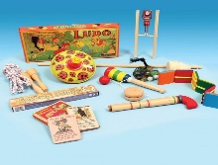 | Why did Mary Seacole and Florence Nightingale change medicine?  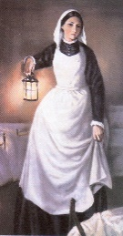 | Who was the greatest explorer?  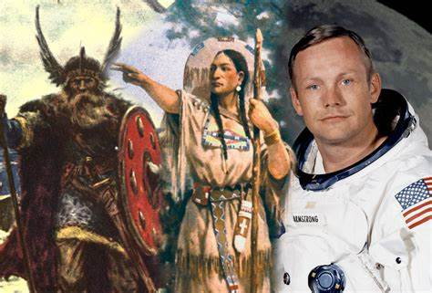
 | Where do people live?  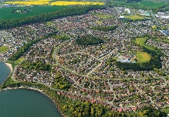 | What is a continent?  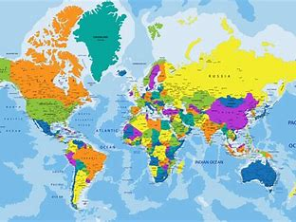 | What is an ocean?  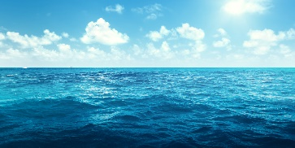
Hook or visit | Local Walk | History Visitor | Aquarium Visit
Year 3 & 4  Year B | How did the Roman invasion change Britain?  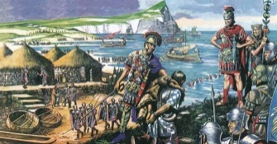 | How did the Anglo Saxons live and work?  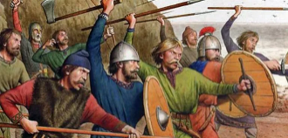 | Why did the Vikings invade Britain?  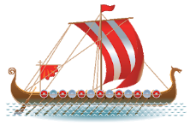
 | Where is all the Earth’s water? | Where are the world’s rivers?  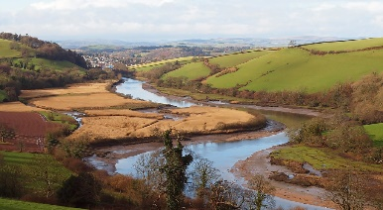 | What is migration? 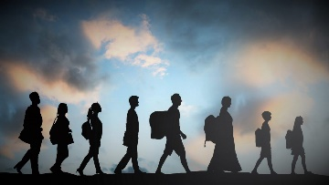
 | Trip to Roman Baths | Trip to River Dart | History Visitor
Year 5 & 6  Year B | How was Plymouth changed by WW2? | How did the British Empire impact the world?  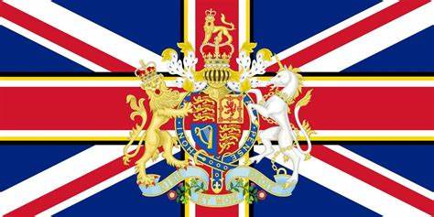 | How did the railways change Devon?  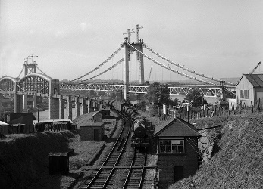
 | What are the countries of Europe?  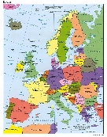 | What is Globalisation?  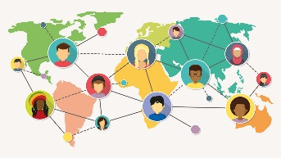 | What are the world’s national resources?  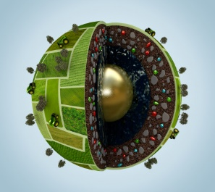
Hook or visit | Plymouth Box Visit | Links with Global Neighbours | Tamar Bridge Visit
Diptford Long Term Curriculum Map Year A

YR R,1 and 2  Year A | How was London changed by the Great Fire of London?  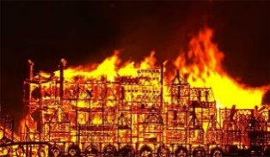 | How did Emily Davidson and Rosa Parks stand up for their beliefs? | How have holidays in Devon changed over time?  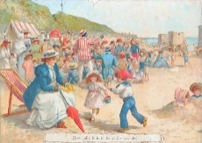
 | Where do I live?  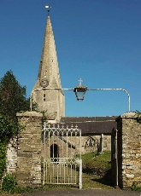 | What is the UK?  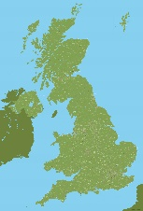 | Where to people like to go on holiday?  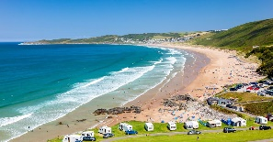
 | Local Walk |  | Beach Visit
Year 3 & 4  Year A | How did the lives of people change in the Stone age?  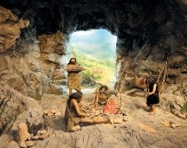 | How did Dartmoor change from the Bronze age to the Iron age? 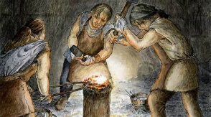 | How did the Ancient Greeks change the world?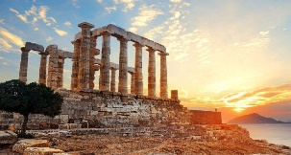
 | What is the Earth made of?  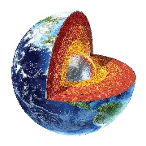 | How are North and South America similar and different?  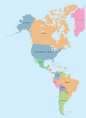 | Where in the world is Greece?  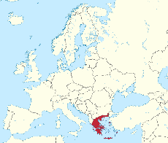
Hook or visit | History Visitor | Visit to Grimspound | Greek Day
Year 5 & 6  Year A | What were the greatest achievements of the Ancient Egyptians?  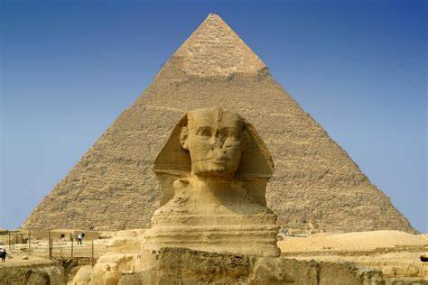 | How did dragon bones help to solve an ancient Chinese mystery?  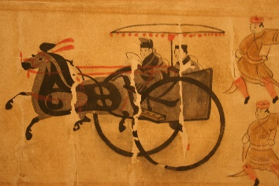 | Why was Totnes castle built? 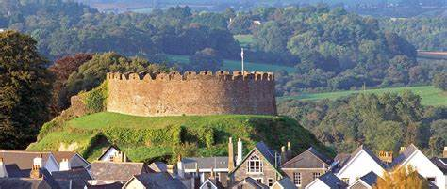
 | What are the hemispheres?  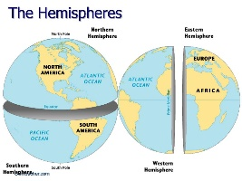 | What are the Earth’s biomes?  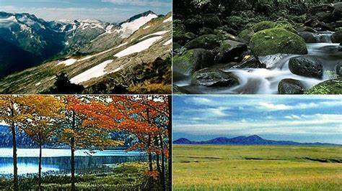 | Where are all the people in the world?
Hook or visit | RAMM visit | Dartmoor Visit | Totnes Castle

