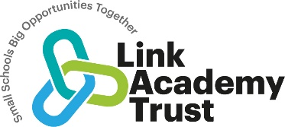
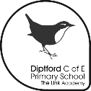
Diptford C of E Primary
Science Curriculum Plan 2023 – 25

Our curriculum statements are designed to be used as a supportive tool to plan teaching and learning across our school.
The key skills are derived from the National Curriculum and spilt into individual year groups to support a progressive approach
As we have mixed age classes, we have developed a rolling programme to ensure coverage of the statutory requirements.

We believe that Science permeates every aspect of our lives, from the technology we use on a daily basis to the natural world around us that sustains life on earth. Igniting children’s curiosity and their passion to question and deepen their knowledge and understanding is central to our role as science teachers. We believe that through science, we can support the development of problem solving, critical thinking, evaluating and communicating that can be applied to the everyday challenges they face. We believe that igniting a passion in Science will give children the tools they need to discuss and debate global issues that will affect their lives and prepare them for a changing future.

We believe that our lessons should be rooted in exploration and development of ideas from one lesson to the next, so they can build on their previous learning creating a solid foundation of knowledge. We believe practical experiences should be meaningful and rigorous and lead children to question what they have done and where they should go next. We believe that Science should be inclusive and create experiences where everyone can take part.

Vocabulary

Children’s command of vocabulary is fundamental to learning and progress across the curriculum. Vocabulary is developed actively, building systematically on pupil’s current knowledge and deepening their understanding. It is essential to introduce technical vocabulary which is essential within each individual curriculum subject. Vocabulary development is underpinned by an oracy culture and a tiered approach. High value is placed on children using the correct scientific vocabulary and to be encouraged both orally and within their written work to ‘talk like a scientist. ‘

KS1 Science Vocabulary List
Plants (Y1)  Leaf, flower, blossom, petal, fruit, berry, root, seed, trunk, branch, stem, bark, stalk, bud | Animals inc Humans (Y1)  Head, body, eyes, ears, mouth, teeth, leg, tail, wing, claw, fin, scales, feathers, fur, beak, paws, hooves | Everyday Materials (Y1)  Object, material, wood, plastic, glass, metal, water, rock, brick, paper, fabric, elastic, foil, card/cardboard, rubber, wool, clay, hard, soft, stretchy, stiff, bendy, floppy, waterproof, absorbent, breaks/tears, rough, smooth, shiny, dull, see-through, not see-through | Seasonal Change (Y1)  Weather (sunny, rainy, windy, snowy etc.)  Seasons (winter, summer, spring, autumn)  Sun, sunrise, sunset, day length | Living Things and their habitats (Y2)  Living, dead, never been alive, suited, suitable, basic needs, food, food chain, shelter, move, feed | Plants (Y2)  As for Year 1 plus light, shade, sun, warm, cool, water, grow, healthy | Animals inc Humans (Y2)  Offspring, reproduction, growth, child, young/old stages (examples - chick/hen, baby/child/adult, caterpillar/butterfly), exercise, heartbeat, breathing, hygiene, germs, disease, food types (examples – meat, fish, vegetables, bread, rice, pasta) | Uses of Everyday Materials (Y2)  As for Year 1 plus  opaque, transparent and translucent, reflective, non-reflective, flexible, rigid  Shape, push/pushing, pull/pulling, twist/twisting, squash/squashing, bend/bending, stretch/stretching

Lower KS2 Science Vocabulary List
Plants (Y3)  Photosynthesis, pollen, insect/wind pollination, seed formation, seed dispersal (wind dispersal, animal dispersal, water dispersal | Animals inc Humans (Y3)  Nutrition, nutrients, carbohydrates, sugars, protein, vitamins, minerals, fibre, fat, water, skeleton, bones, muscles, joints, support, protect, move, skull, ribs, spine | Rocks (Y3)  Rock, stone, pebble, boulder, grain, crystals, layers, hard, soft, texture, absorb water, soil, fossil, marble, chalk, granite, sandstone, slate, soil, peat, sandy/chalk/clay soil | Light (Y3)  Light, light source, dark, absence of light, transparent, translucent, opaque, shiny, matt, surface, shadow, reflect, mirror, sunlight, dangerous | Forces and Magnets (Y3)  Force, push, pull, twist, contact force, non-contact force, magnetic force, magnet, strength, bar magnet, ring magnet, button magnet, horseshoe magnet, attract, repel, magnetic material, metal, iron, steel, poles, north pole, south pole | Living Things and their habitats (Y4)  Classification, classification keys, environment, habitat, human impact, positive, negative, migrate, hibernate | Animals inc Humans (Y4)  Digestive system, digestion, mouth, teeth, saliva, oesophagus, stomach, small intestine, nutrients, large intestine, rectum, anus, teeth, incisor, canine, molar, premolars, herbivore, carnivore, omnivore, producer, predator, prey, food chain | States of Matter (Y4)  Solid, liquid, gas, state change, melting, freezing, melting point, boiling point, evaporation, temperature, water cycle
Sound (Y4)  Sound, source, vibrate, vibration, travel, pitch (high, low), volume, faint, loud, insulation | Electricity (Y4)  Electricity, electrical appliance/device, mains, plug, electrical circuit, complete circuit, component, cell, battery, positive, negative, connect/connections, loose connection, short circuit, crocodile clip, bulb, switch, buzzer, motor, conductor, insulator, metal, non-metal, symbol

Upper KS2 Science Vocabulary List
Living Things and their habitats (Y5)  Life cycle, reproduce, sexual, sperm, fertilises, egg, live young, metamorphosis, asexual, plantlets, runners, bulbs, cuttings | Animals including Humans (Y5)  Human development, baby, toddler, child, teenage, adult, puberty, gestation, length, mass, grow, grows, growing | Properties and Changes of Materials (Y5)  Thermal/electrical insulator/conductor, change of state, mixture, dissolve, solution, soluble, insoluble, filter, sieve, reversible/non-reversible change, burning, rusting, new material | Earth and Space (Year 5)  Earth, Sun, Moon, (Mercury, Jupiter, Saturn, Venus, Mars, Uranus, Neptune), spherical, solar system, rotates, star, orbit, planets | Forces (Y5)  Force, gravity, Earth, air resistance, water resistance, friction, mechanisms, simple machines, levers, pulleys, gears | Living Things and their habitats (Y6)  Vertebrates, fish, amphibians, reptiles, birds, mammals, invertebrates, insects, spiders, snails, worms, flowering, non-flowering | Animals inc Humans (Y6)  Heart, pulse, rate, pumps, blood, blood vessels, transported, lungs, oxygen, carbon dioxide, nutrients, water, muscles, cycle, circulatory system, diet, exercise, drugs, lifestyle | Evolution and Inheritance (Y6)  Offspring, sexual reproduction, vary, characteristics, suited, adapted, environment, inherited, species, fossils | Light (Y6)  Light, light source, dark, absence of light, transparent, translucent, opaque, shiny, matt, surface, shadow, reflect, mirror, sunlight, dangerous straight lines, light ray
Electricity (Y6)
Circuit, complete circuit, circuit diagram, circuit symbol, cell, battery, bulb, buzzer, motor, switch, voltage
As a small school, with mixed age classes, we have planned a two-year rolling programme to ensure our children that all aspects of the national curriculum programmes of study are taught to all pupils. Our rolling program groups units that deal with similar concepts together to enable complete coverage of all curriculum objectives over 2 years. For the academic year 2023/24, we have identified some gaps in previous years due to the Covid 19 pandemic and will be following an interim year for year 5 and 6 to ensure that they receive full access to the NC science objectives by the time they leave Diptford.

To support teachers in the delivery of the Science curriculum the “Plan Assessment” resources are used to provide a skeleton structure. Teachers use these to plan and deliver a unit of work that allows children to progress and build on prior learning. This resource supports teachers in driving pupil progress and helps learners a develop secure understanding of each key block of knowledge in order to progress to the next stage.
Each lesson has a knowledge objective and a working scientifically objective ( substantive knowledge and disciplinary knowledge) This ensures that knowledge is developed through an enquiry approach and the two areas do not stand alone. As the children’s knowledge and understanding increases, they become more proficient in selecting, using scientific equipment, collating, and interpreting results, they become increasingly confident in their growing ability to come to conclusions based on real evidence. Pupils learn to use the five types of scientific enquiry, and these are incorporated over a year of teaching to ensure that children have the opportunity to:
- observe over time
- pattern seek
- identifying, classify and group
- carry out comparative and fair testing
- research using secondary sources.
Science is taught weekly allowing for the progressive building of skills and knowledge and allows children to visit all sections of the plan, do review cycle of investigation. A positive and encouraging classroom environment can be found across all Key Stages. Children’s questions are always welcomed, and they are given the opportunity to explore new ideas as well as test them. Curiosity is celebrated within the classroom and when we assess their prior knowledge, we also seek to record their questions and ideas for investigations.
We seek opportunities to develop Science Capital with Science visits and visitors as well as valuing the experiences and expertise they bring to the lesson.
We teach Science with inclusion in mind, using technology to support children who find sharing their ideas through writing a barrier to their communication. The use of video recording plays an important part in giving all children a voice and allowing them to contribute on an equal footing.
Science Rolling Programme:

Teachers in our EYFS stage use the plan assessment document below and the additional matrices to plan early opportunities to develop curiosity, interest and excitement about science as well as knowledge as part of their planning for the area of learning ‘ Understanding the World.’ Activities will be provided as part of continuous and enhanced provision.

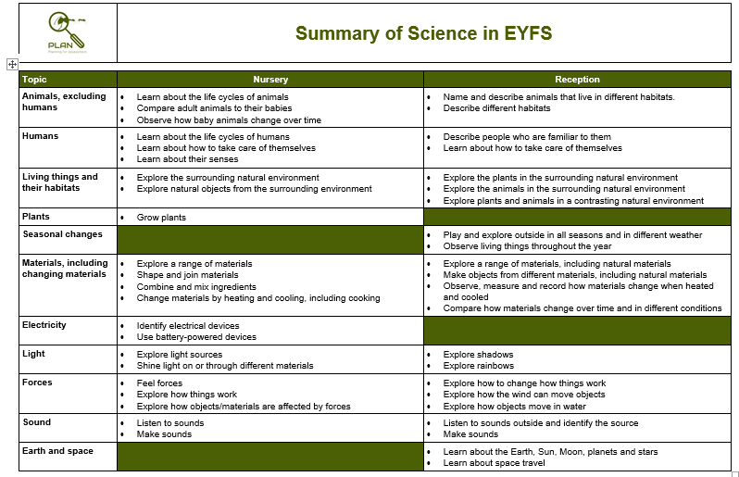

Diptford Rolling Programme 2023 -25
Y1/Y2 | Autumn | Spring | Summer
2023/24 | Animals including humans (Y1)  - identify and name a variety of common animals including fish, amphibians, reptiles, birds and mammals  - identify and name a variety of common animals that are carnivores, herbivores and omnivores  - describe and compare the structure of a variety of common animals (fish, amphibians, reptiles, birds and mammals including pets)  - identify, name, draw and label the basic parts of the human body and say which part of the body is associated with each sense | Animals including humans (Y2)  - notice that animals, including humans, have offspring which grow into adults  - find out about and describe the basic needs of animals, including humans, for survival (water, food and air)  - describe the importance for humans of exercise, eating the right amounts of different types of food, and hygiene | Plants (Y1)  - identify and name a variety of common wild and garden plants, including deciduous and evergreen trees  - identify and describe the basic structure of a variety of common flowering plants, including trees  Plants (Y2)  - observe and describe how seeds and bulbs grow into mature plants  - find out and describe how plants need water, light and a suitable temperature to grow and stay healthy
Seasonal Changes (Y1) to run throughout the year on both phases.
- observe changes across the 4 seasons
- observe and describe weather associated with the seasons and how day length varies
2024/25 | Everyday Materials (Y1)  - distinguish between an object and the material from which it is made  - identify and name a variety of everyday materials, including wood, plastic, glass, metal, water, and rock  - describe the simple physical properties of a variety of everyday materials  - compare and group together a variety of everyday materials on the basis of their simple physical properties | Everyday Materials (Y2)  - identify and compare the suitability of a variety of everyday materials, including wood, metal, plastic, glass, brick, rock, paper and cardboard for particular uses  - find out how the shapes of solid objects made from some materials can be changed by squashing, bending, twisting and stretching | Living things and their habitats (Y2)  - explore and compare the differences between things that are living, dead, and things that have never been alive  - identify that most living things live in habitats to which they are suited and describe how different habitats provide for the basic needs of different kinds of animals and plants, and how they depend on each other  - identify and name a variety of plants and animals in their habitats, including microhabitats  - describe how animals obtain their food from plants and other animals, using the idea of a simple food chain, and identify and name different sources of food
Seasonal Changes (Y1) to run throughout the year on both phases.
- observe changes across the 4 seasons
observe and describe weather associated with the seasons and how day length varies

Y3/4 | Autumn | Spring | Summer
2023/24 | Animals including humans (Y3 & Y4)  Y3  - identify that animals, including humans, need the right types and amount of nutrition, and that they cannot make their own food; they get nutrition from what they eat  - identify that humans and some other animals have skeletons and muscles for support, protection and movement  Y4  - describe the simple functions of the basic parts of the digestive system in humans  - identify the different types of teeth in humans and their simple functions  - construct and interpret a variety of food chains, identifying producers, predators and prey | Electricity (Y4)  - identify common appliances that run on electricity  - construct a simple series electrical circuit, identifying and naming its basic parts, including cells, wires, bulbs, switches and buzzers  - identify whether or not a lamp will light in a simple series circuit, based on whether or not the lamp is part of a complete loop with a battery  - recognise that a switch opens and closes a circuit and associate this with whether or not a lamp lights in a simple series circuit  - recognise some common conductors and insulators, and associate metals with being good conductors  States of matter (Y4)  - compare and group materials together, according  to whether they are solids, liquids or gases  - observe that some materials change state when  they are heated or cooled, and measure or  research the temperature at which this happens  in degrees Celsius (°C)  - identify the part played by evaporation and  condensation in the water cycle and associate  the rate of evaporation with temperature | Plants (Y3)  - identify and describe the functions of different  parts of flowering plants: roots, stem/  trunk, leaves and flowers  - explore the requirements of plants for life  and growth(air, light, water, nutrients from soil,  and room to grow) and how they vary from plant to  plant investigate the way in which water is  transported within plants  - explore the part that flowers play in the life cycle  - of flowering plants, including pollination, seed  - formation and seed dispersal
2024/25 | Light (Y3)  - recognise that they need light in order to see things and that dark is the absence of light  - notice that light is reflected from surfaces  - recognise that light from the sun can be dangerous and that there are ways to protect their eyes  - recognise that shadows are formed when the light from a light source is blocked by an opaque object  - find patterns in the way that the size of shadows change  Sound (Y4)  - identify how sounds are made, associating some of them with something vibrating  - recognise that vibrations from sounds travel through a medium to the ear  - find patterns between the pitch of a sound and features of the object that produced it  - find patterns between the volume of a sound and the strength of the vibrations that produced it  - recognise that sounds get fainter as the distance from the sound source increases | Rocks (Y3)  - compare and group together different kinds of rocks on the basis of their appearance and simple physical properties  - describe in simple terms how fossils are formed when things that have lived are trapped within rock  - recognise that soils are made from rocks and organic matter  Forces and magnets (Y3)  - compare how things move on different surfaces  - notice that some forces need contact between 2 objects, but magnetic forces can act at a distance  - observe how magnets attract or repel each other and attract some materials and not others  - compare and group together a variety of everyday materials on the basis of whether they are attracted to a magnet, and identify some magnetic materials  - describe magnets as having 2 poles  - predict whether 2 magnets will attract or repel each other, depending on which poles are facing | Living things and their habitats (Y4)  - recognise that living things can be grouped in a  variety of ways  - explore and use classification keys to help group,  identify and name a variety of living things in  their local  and wider environment  - recognise that environments can change and  that this can sometimes pose dangers to living  things  Practical action:  Global Context - Pumpkins Against Poverty  See which flowering plants grow in countries around the  world  https://practicalaction.org/schools-pumpkins
Yr 5/6 | Autumn | Spring | Summer
Interim Year  2023/24 | Properties and changes (Y5)  - compare and group together everyday materials on the basis of their properties, including their hardness, solubility, transparency, conductivity (electrical and thermal), and response to magnets  - know that some materials will dissolve in liquid to form a solution, and describe how to recover a substance from a solution  - use knowledge of solids, liquids and gases to decide how mixtures might be separated, including through filtering, sieving and evaporating  - give reasons, based on evidence from comparative and fair tests, for the particular uses of everyday materials, including metals, wood and plastic  - demonstrate that dissolving, mixing and changes of state are reversible changes  - explain that some changes result in the formation of new materials, and that this kind of change is not usually reversible, including changes associated with burning and the action of acid on bicarbonate of soda  Global Context - Ditch the Dirt  Enables pupils to investigate ways of making dirty water cleaner through sieving and filtering and can also be used to explore ways of making water safe to drink.  https://practicalaction.org/ditch-the-dirt  Electricity (Y6)  - associate the brightness of a lamp or the volume of a buzzer with the number and voltage of cells used in the circuit  - compare and give reasons for variations in how components function, including the brightness of bulbs, the loudness of buzzers and the on/off position of switches  - use recognised symbols when representing a simple circuit in a diagram | Evolution and inheritance (Y6)  - recognise that living things have changed over time and that fossils provide information about living things that inhabited the Earth millions of years ago  - recognise that living things produce offspring of the same kind, but normally offspring vary and are not identical to their parents  - identify how animals and plants are adapted to suit their environment in different ways and that adaptation may lead to evolution | Living things and their habitats Y6  - describe how living things are classified into  broad groups according to common  observable characteristics and based on  similarities and differences, including  micro-organisms, plants and animals  - give reasons for classifying plants and animals  based on specific characteristics  Animals including humans (Y5 & Y6)  Y5  - describe the changes as humans develop to  old age  Y6  - identify and name the main parts of the  human circulatory system, and describe  the functions of the heart, blood vessels  and blood  - recognise the impact of diet,  exercise, drugs and lifestyle on the way  their bodys’ function  - describe the ways in which nutrients and  water are transported within animals,  including humans
2024/5 | Forces (Y5)  - explain that unsupported objects fall towards the Earth because of the force of gravity acting between the Earth and the falling object  - identify the effects of air resistance, water resistance and friction, that act between moving surfaces  - recognise that some mechanisms including levers, pulleys and gears allow a smaller force to have a greater effect  Global Context - The Squashed Tomato Challenge  Use of levers, pulleys etc. to transport people and produce in the developing world  https://practicalaction.org/squashed-tomato-challenge-5  Light (Y6)  - recognise that light appears to travel in straight lines  - use the idea that light travels in straight lines to explain that objects are seen because they give out or reflect light into the eye  - explain that we see things because light travels from light sources to our eyes or from light sources to objects and then to our eyes  - use the idea that light travels in straight lines to explain why shadows have the same shape as the objects that cast them | Earth and Space (Y5)  - describe the movement of the Earth and other planets relative to the sun in the solar system  - describe the movement of the moon relative to the Earth  - describe the sun, Earth and moon as approximately spherical bodies  - use the idea of the Earth's rotation to explain day and night and the apparent movement of the sun across the sky | Living things and their habitats (Y5)  - describe the differences in the life cycles of  - a mammal, an amphibian, an insect and a bird  - describe the life process of reproduction in  some plants and animals
2025/26 | Properties and changes (Y5)  - compare and group together everyday materials on the basis of their properties, including their hardness, solubility, transparency, conductivity (electrical and thermal), and response to magnets  - know that some materials will dissolve in liquid to form a solution, and describe how to recover a substance from a solution  - use knowledge of solids, liquids and gases to decide how mixtures might be separated, including through filtering, sieving and evaporating  - give reasons, based on evidence from comparative and fair tests, for the particular uses of everyday materials, including metals, wood and plastic  - demonstrate that dissolving, mixing and changes of state are reversible changes  - explain that some changes result in the formation of new materials, and that this kind of change is not usually reversible, including changes associated with burning and the action of acid on bicarbonate of soda  Global Context - Ditch the Dirt  Enables pupils to investigate ways of making dirty water cleaner through sieving and filtering and can also be used to explore ways of making water safe to drink.  https://practicalaction.org/ditch-the-dirt  Living things and their habitats( Yr6)  Pupils should be taught to:  - describe how living things are classified into broad groups according to common observable characteristics and based on similarities and differences, including micro-organisms, plants and animals  - give reasons for classifying plants and animals based on specific characteristics | Electricity (Y6)  - associate the brightness of a lamp or the volume of a buzzer with the number and voltage of cells used in the circuit  - compare and give reasons for variations in how components function, including the brightness of bulbs, the loudness of buzzers and the on/off position of switches  - use recognised symbols when representing a simple circuit in a diagram  Evolution and inheritance (Y6)  - recognise that living things have changed over time and that fossils provide information about living things that inhabited the Earth millions of years ago  - recognise that living things produce offspring of the same kind, but normally offspring vary and are not identical to their parents  - identify how animals and plants are adapted to suit their environment in different ways and that adaptation may lead to evolution | Animals including humans (Y5 & Y6)  Y5  - describe the changes as humans develop to  old age  Y6  - identify and name the main parts of the  - human circulatory system, and describe  the functions of the heart, blood vessels and  blood  - recognise the impact of diet, exercise, drugs  and  lifestyle on the way their body’s function  - describe the ways in which nutrients and  water are transported within animals, including humans

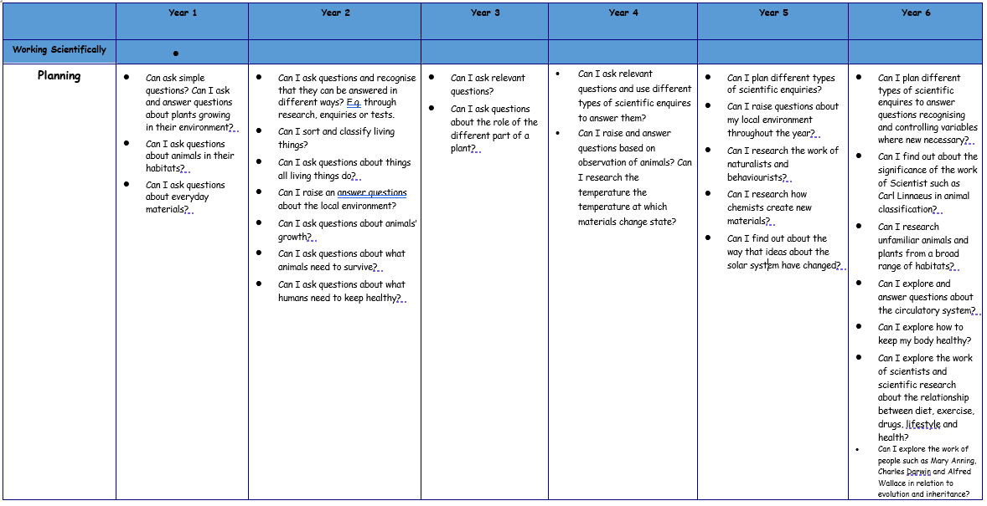
Progression of skills

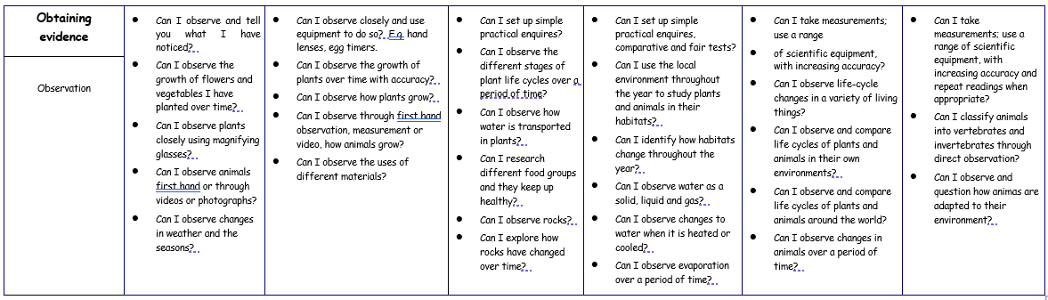

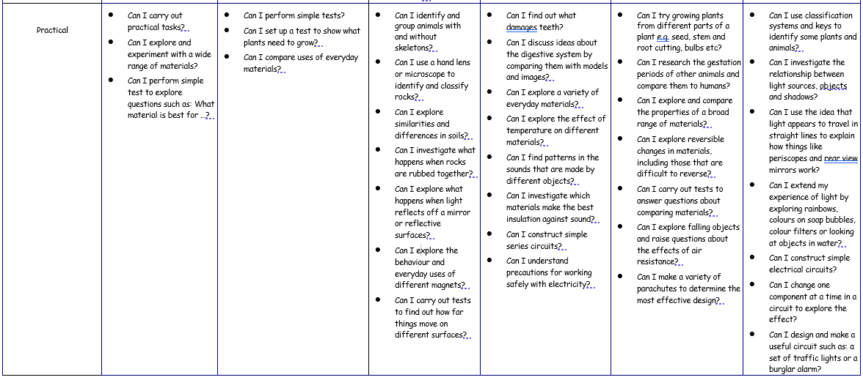

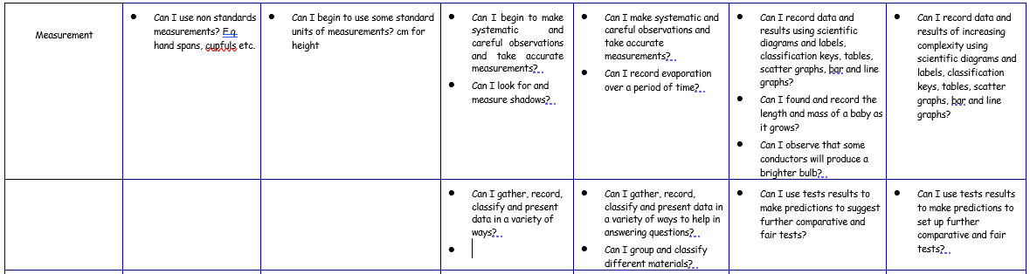

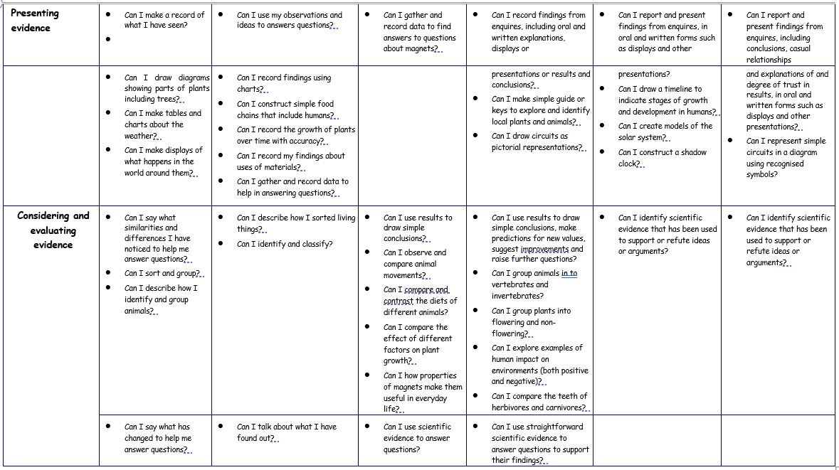

In order to assess impact - a guide
At the beginning of each unit an assessment of prior knowledge is carried out. This may take the form of an assessment proforma, a discovery activity, a knowledge download page or a video of children talking about what they already know. In many cases, a combination of these methods is used. At the end of each unit of work, assessments are also recorded on the Plan Assessment Matrices assessment document to enable monitoring of progress against the objectives.

During each teaching unit, teachers use AFL to pick up on misconceptions that occur during the lesson which will be addressed on the spot or within a follow up activity. Teachers also assess children’s working scientifically skills during the lesson and look for areas that require further development. A final judgement for working scientifically is only made at the end of the year when children have had the opportunity to explore all aspects of the investigation cycle and had the opportunity to make these skills more substantive.

The progress of children with SEND who find writing and communication a barrier to completing a written assessment may be assessed in different ways ensuring that children have the opportunity to express and explain their knowledge and understanding. From this, the teacher is able to make a judgement of progress achieved from the beginning to the end of the unit.

There is an expectation that work in science books will be the same quality as that in English books with regard to presentation and writing when work is recorded.

