**Umbrella Narrative**

Final event:

Learn about Sir Francis Drake, create treasure maps, messages in a bottle.

Design a pirate ship

English

Books:

**Sully the Seahorse** – we will be starting the term off by learning the story of Sully the Seahorse. We will then be changing the story and creating our own characters.

**Penguins** – we will be become Penguin detectives and learn about the different varieties, where they live and what they eat. We will make our own book using the information we find out.

The Rainbow Fish

**HOOK:**

Let’s become pirates!

Make treasure for our treasure chest which will go into our pirate ship. 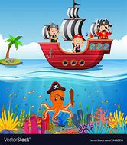

***Dippers Class***

***Sail the seven seas***

***Spring 2020***

**RE – which places are special and why?**

Where is special to me

Where is special for Christians?

What makes a church a special place for Christians?

Where is a special place for Muslims?

Why is a mosque special for Muslims?

**Art/D&T**

Design, make and evaluate your own pirate ship. Experiment with different materials to make an underwater scene.

PE

PE will continue to happen on Wednesday mornings with Mr Tanner.

Maths

This term we are learning about:

* Time
* Place value
* Length
* Height
* Addition and subtraction

*Sail the seven seas*

Phonics

Reception: Phase 3 phonics

Year 1: Phase 5 phonics



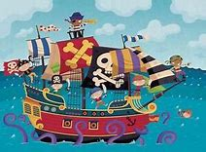

Science – Everyday materials

* Naming objectives
* Identifying their material
* Investigating which are waterproof
* Investigating which materials float and sink

Understanding the World

We will be:

* Investigating objects that float and sink
* Making felt sea creatures
* Making a pirate ship
* Creating a rock pool

Computing

* Using Beebots – programming and giving directions to navigate across the ‘sea’