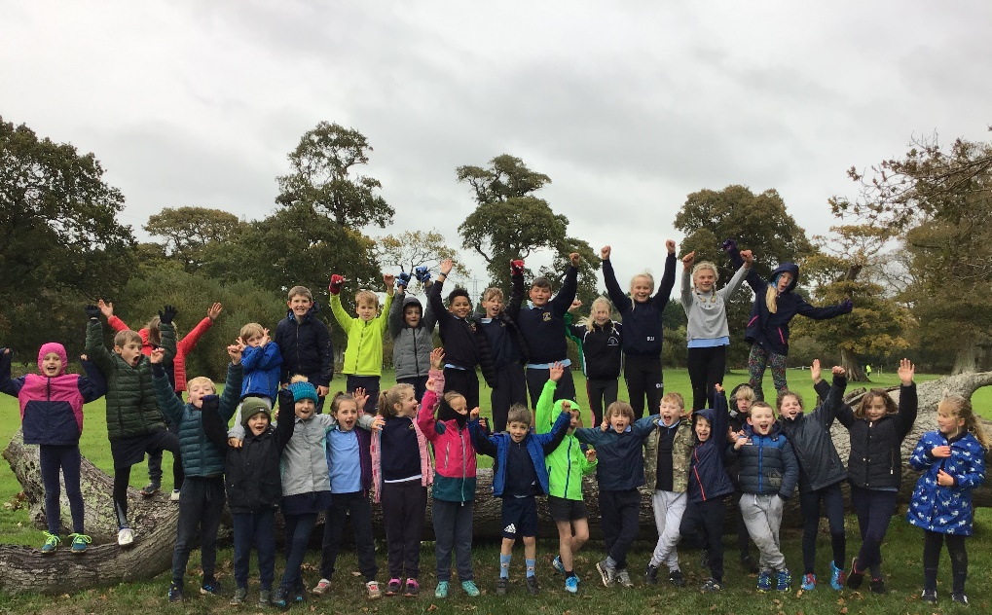
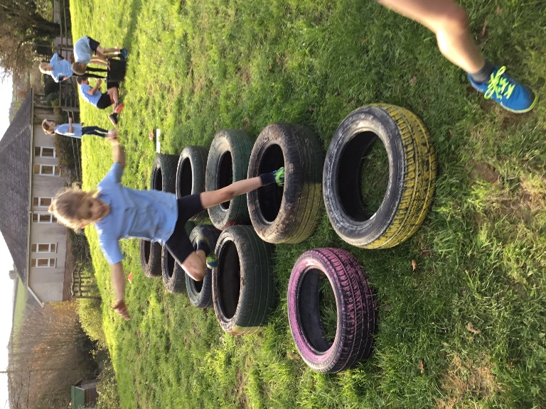
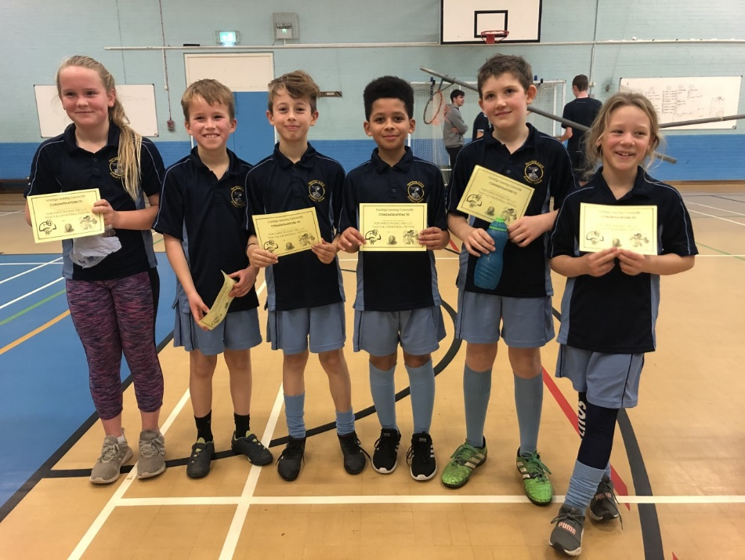
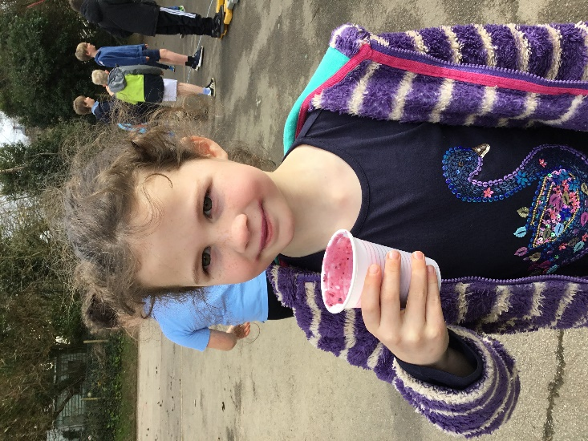
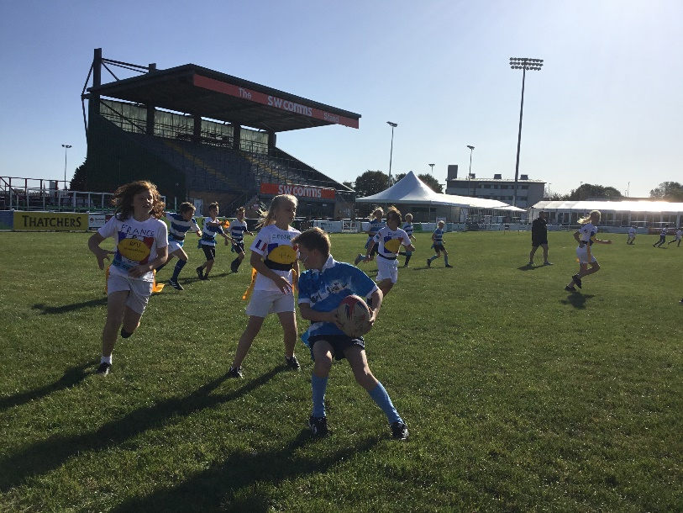
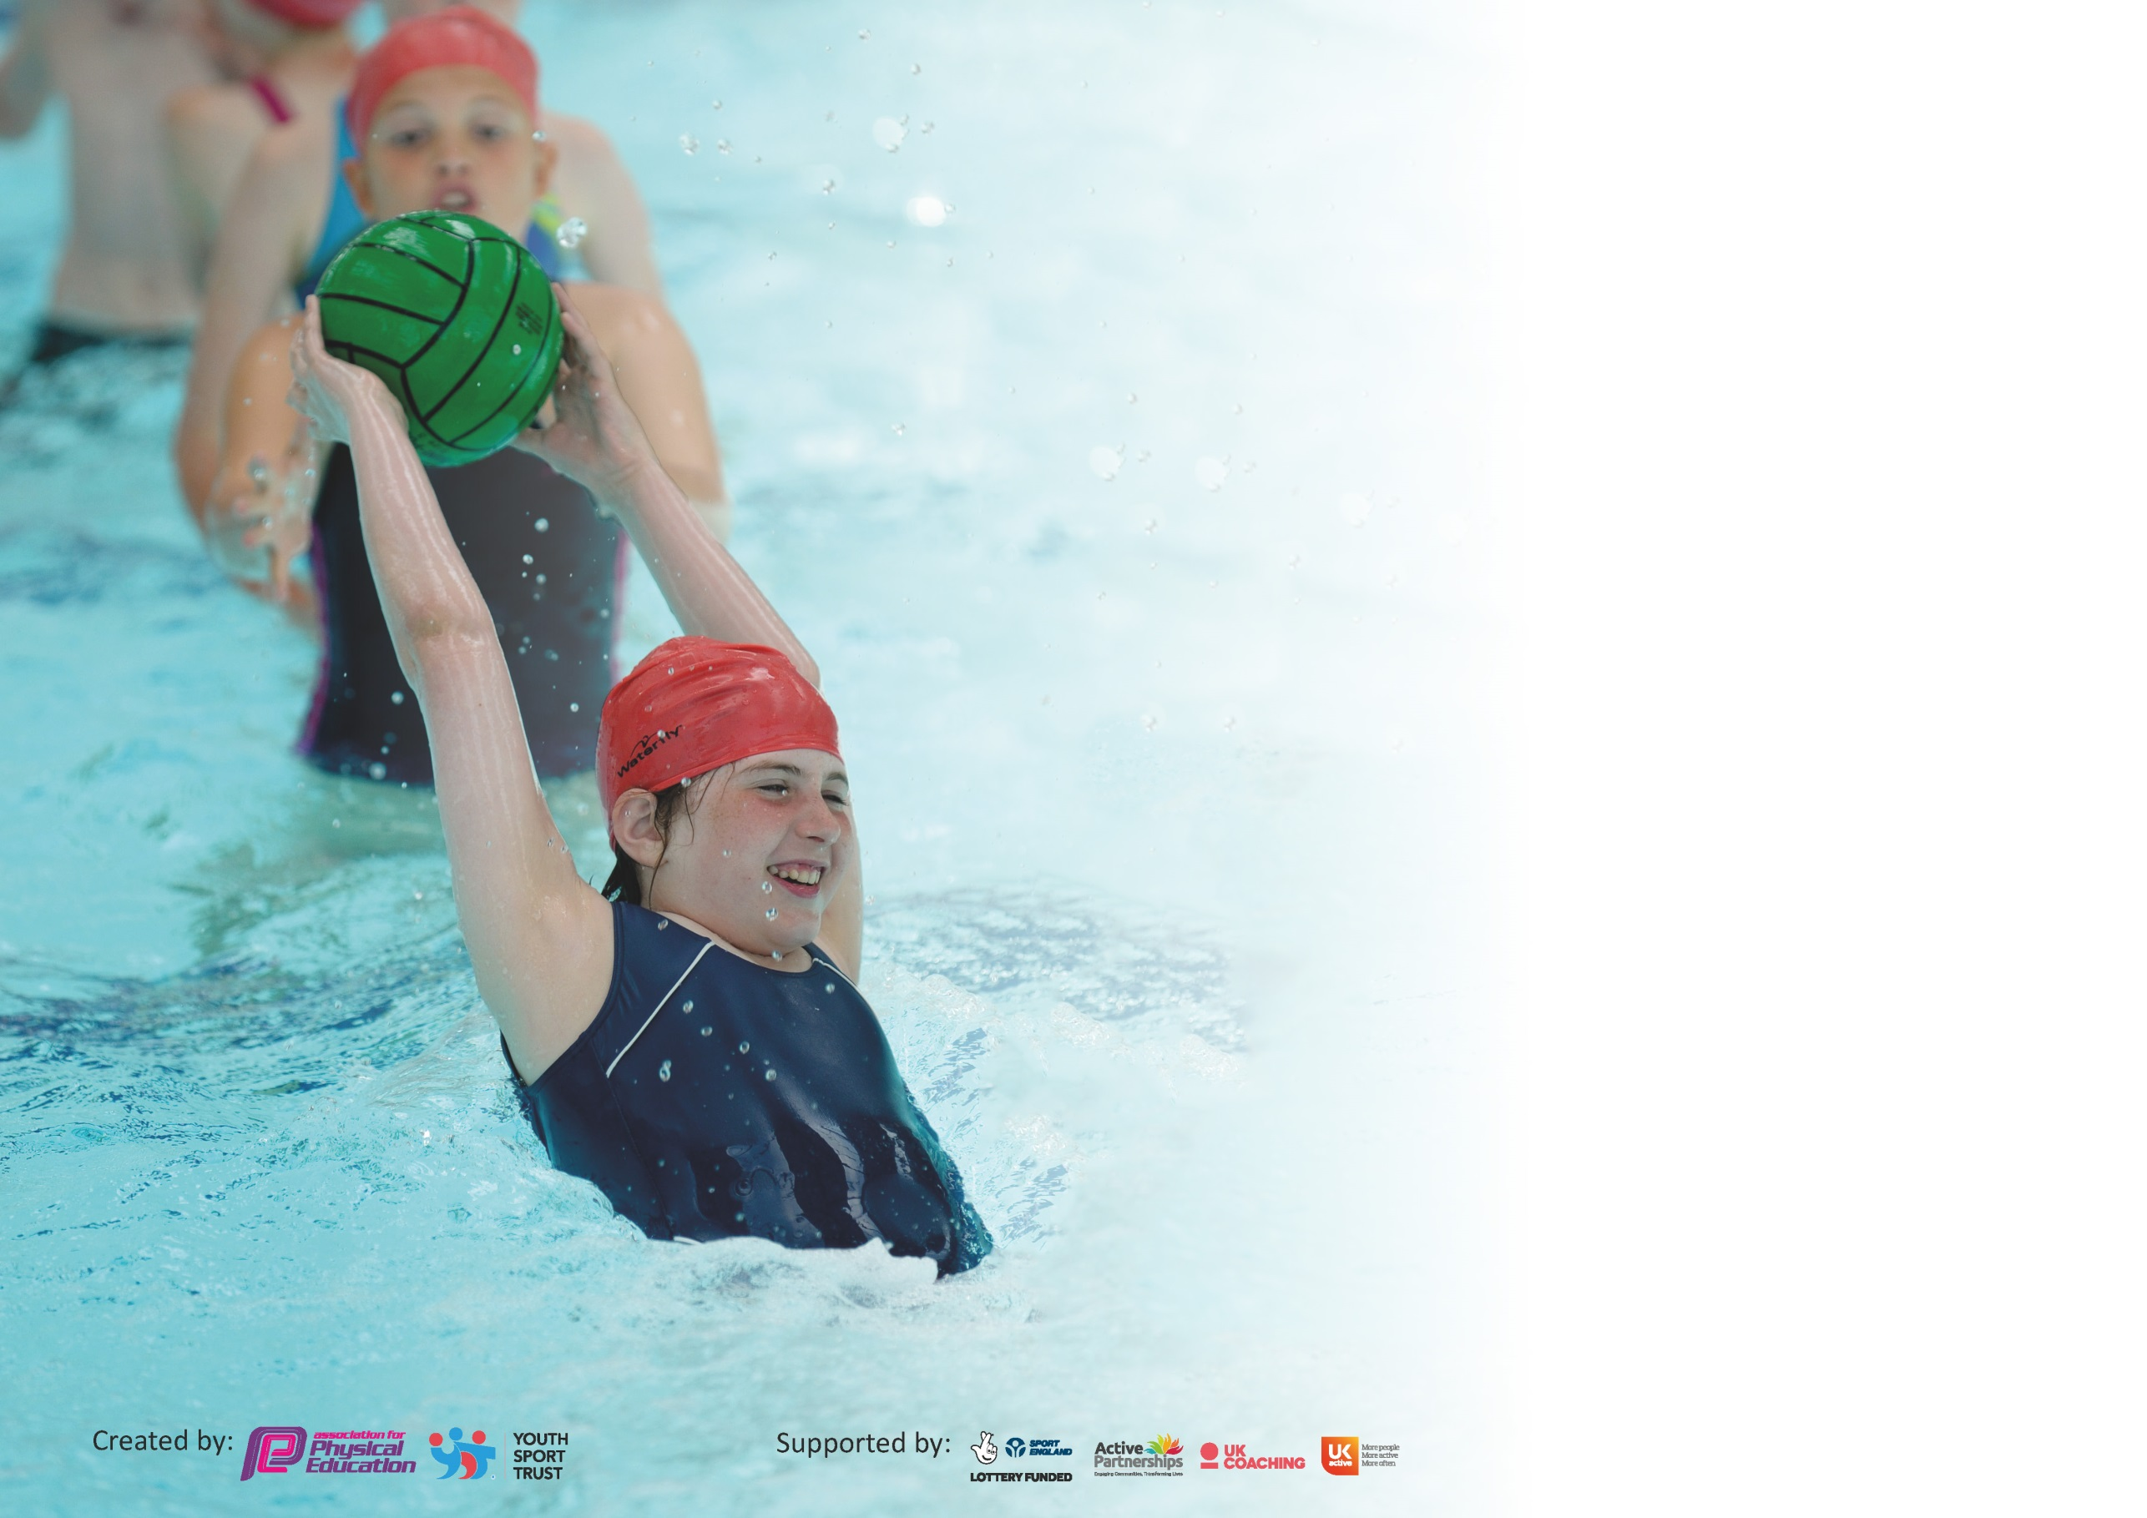

It is important that your grant is used effectively and based on school need. The Education Inspection Framework (Ofsted 2019 p64) makes clear there will be a focus on ‘whether leaders and those responsible for governors all understand their respective roles and perform these in a way that enhances the effectiveness of the school’.

Under the Quality of Education criteria (p41) inspectors consider the extent to which schools can articulate their curriculum (INTENT), construct their curriculum (IMPLEMENTATION) and demonstrate the outcomes which result (IMPACT).

To assist schools with common transferable language this template has been developed to utilise the same three headings which should make your plans easily transferable between working documents.

Schools must use the funding to make additional and sustainable improvements to the quality of Physical Education, School Sport and Physical Activity (PESSPA) they offer. This means that you should
use the Primary PE and Sport Premium to:

- Develop or add to the PESSPA activities that your school already offer
- Build capacity and capability within the school to ensure that improvements made now will benefit pupils joining the school in future years

Please visit gov.uk for the revised DfE guidance including the 5 key indicators across which schools should demonstrate an improvement. This document will help you to review your provision and to report your spend. DfE encourages schools to use this template as an effective way of meeting the reporting requirements of the Primary PE and Sport Premium.

We recommend you start by reflecting on the impact of current provision and reviewing the previous spend.

Schools are required to publish details of how they spend this funding as well as on the impact it has on pupils’ PE and sport participation and attainment by the end of the summer term or by 31st July 2020 at the latest.

We recommend regularly updating the table and publishing it on your website throughout the year. This evidences your ongoing self-evaluation of how you are using the funding to secure maximum, sustainable impact. Final copy must be posted on your website by the end of the academic year and no later than the 31st July 2020. To see an example of how to complete the table please click HERE.

Support for review and reflection - considering the 5 key indicators from DfE, what development needs are a priority for your setting and your pupils now and why? Use the space below to reflect on previous spend and key achievements and areas for development.

Key achievements to date until July 2019: | Areas for further improvement and baseline evidence of need:
- Children participate in a morning routine involving physical activity every day  - PE lessons are occurring at least twice a week (2 hours)  - Healthy Living Week ran for a week and allowed children to experience a range of new and adventurous activities  - Residentials occurred for every KS2 child  - All children have competed in inter-school sports and intra-school competitions across the academy  - Most children have competed in intra-school competitions as part of SSP  - Children in Y3/4 participate in a 6 week block of swimming  - Sports recognitions during celebration assemblies (Sports Star of the Week/Achievements from outside of school) | - Develop House Teams and introduce more inter-house/school competitions and events across the school  - Rethink morning routine with a running challenge (Diptford Daily Dash) to link with personal best (see below) and House Team Challenges  - Introduce personal best recording (as part of Diptford Daily Dash)  - Greater promotion of Sports Star of the week – potential for sports star of the half term/sportsmanship award  - Consider swimming interventions for children past Y3/4 who still might not be able to swim effectively or efficiently  - Look in to greater promotion of sports clubs and prolonging participation in sport (have visitors in and events at local sports clubs)  - Ensure efficient equipment has been purchased to effectively teach PE (in line with curriculum map and rolling programme)  - Fundraising and building a new outdoor play area (including jungle gym/assault course style climbing frames)

Meeting national curriculum requirements for swimming and water safety.
What percentage of your current Year 6 cohort swim competently, confidently and proficiently over a distance of at least 25 metres?  N.B. Even though your pupils may swim in another year please report on their attainment on leaving  primary school at the end of the summer term 2020. | %
What percentage of your current Year 6 cohort use a range of strokes effectively [for example, front crawl, backstroke and breaststroke]? | %
What percentage of your current Year 6 cohort perform safe self-rescue in different water-based situations? | %
Schools can choose to use the Primary PE and Sport Premium to provide additional provision for swimming but this must be for activity over and above the national curriculum requirements. Have you used it in this way? | Yes/No

Action Plan and Budget Tracking
Capture your intended annual spend against the 5 key indicators. Clarify the success criteria and evidence of impact that you intend to measure to evaluate for pupils today and for the future.

Academic Year: 2019/20 | Total fund allocated: £16,498 | Date Updated: January 2020
Key indicator 1: The engagement of all pupils in regular physical activity – Chief Medical Officer guidelines recommend that primary school pupils undertake at least 30 minutes of physical activity a day in school |  |  |  | Percentage of total allocation:
 |  |  |  | 48%
Intent | Implementation |  | Impact
Your school focus should be clear what you want the pupils to know and be able to do and about  what they need to learn and to  consolidate through practice: | Make sure your actions to achieve are linked to your intentions: | Funding allocated: | Evidence of impact: what do pupils now know and what can they now do? What has changed?: | Sustainability and suggested next steps:
All children have 2 hours of PE teaching per week within lesson times (with the addition of Fun Fit interventions and competitions/festivals)  All children to be taking part in physical activity every day. | Class teacher will teach one lesson a week with the other being taught by the Academy PE Coordinator.  Introduce ‘Diptford Daily Dash’ where children run in the mornings around the playground. Children to count their laps and record this as part of house teams as an incentive to run more/take part. | £7908 (as part of central money in the Academy)  £0 (teacher time)
Key indicator 2: The profile of PESSPA being raised across the school as a tool for whole school improvement |  |  |  | Percentage of total allocation:
 |  |  |  | 27%
Intent | Implementation |  | Impact
Your school focus should be clear what you want the pupils to know and be able to do and about  what they need to learn and to  consolidate through practice: | Make sure your actions to achieve are linked to your intentions: | Funding allocated: | Evidence of impact: what do pupils now know and what can they now do? What has changed?: | Sustainability and suggested next steps:
Suitable equipment is available to effectively teaching PE across every age group, in accordance to the curriculum map.  Extra-curricular opportunities for every child from YR to Y6.  Opportunities to attended sport events within the wider community.  Appreciation and celebration of global events, e.g. Rugby World Cup, 6 Nations, Olympic/Paralympic Games. | Order new PE equipment for lessons, in line with the Academy curriculum map programme.  Range of sports and activities available to suit different interests and areas of PA and Sport through the organisation and running of an after-school club. To include a sport specific club/s and more generalised ball skills and PA.  Arrange visits with local professional sports teams (Plymouth Albion/Argyle/Raiders), including Plymouth Albion Super Saturday opportunity.  Run a ‘mini-Olympics’ as part of sports day routines to promote physical activity alongside Tokyo 2020 Olympics. Purchase medals/trophy for winning house/certificates.  Make links across the curriculum to promote sport and PA. E.g. Researching sports and different countries as part of the Olympics. | £800  £3500  £100  £50  £0 (teacher time)

Key indicator 3: Increased confidence, knowledge and skills of all staff in teaching PE and sport |  |  |  | Percentage of total allocation:
 |  |  |  | 0%
Intent | Implementation |  | Impact
Your school focus should be clear | Make sure your actions to | Funding | Evidence of impact: what do | Sustainability and suggested
what you want the pupils to know | achieve are linked to your | allocated: | pupils now know and what | next steps:
and be able to do and about | intentions: |  | can they now do? What has
what they need to learn and to |  |  | changed?:
consolidate through practice:
Teachers to be confident in teaching a range of sports and activities and understand the progressions involved.  Team Teaching and ‘informal’ observations to ensure consistency and development of teaching. | Link PE Lead to be shadowed by teachers when teaching to act as CPD. Teachers to also plan and team-teach with PE Lead to help develop skills and knowledge, in turn boosting their confidence.  PE Lead to ‘observe’ teachers once to monitor consistency and quality of PE delivery (depending on experience and confidence).  Teachers to team-teach one lesson with Academy PE Lead once a half term (once per sport). | £0 (as part of central pot)  £0 (teacher time)  £0 (teacher time)
Key indicator 4: Broader experience of a range of sports and activities offered to all pupils |  |  |  | Percentage of total allocation:
 |  |  |  | 9%
Intent | Implementation |  | Impact
Your school focus should be clear | Make sure your actions to | Funding | Evidence of impact: what do | Sustainability and suggested
what you want the pupils to know | achieve are linked to your | allocated: | pupils now know and what | next steps:
and be able to do and about | intentions: |  | can they now do? What has
what they need to learn and to |  |  | changed?:
consolidate through practice:
Curriculum map has been designed by PE leads from across the academy to ensure all children are getting exposure to a range of activities also.  Forest School to provide outdoor education.  Children to experience alternative or adventurous activities.  Every child can swim 25m by the end of Y6 and confidently perform water safety (in line with NC requirements) | Check curriculum map at PE leader hub meetings. Ensure activities are not repeated (unless necessary) to provide a range of sports.  Forest School trained lead (from within the Academy) to run sessions with KS2 and Teacher to run outdoor sessions with KS1. Children to have suitable and adequate equipment available to take part in outdoor education.  Healthy Living week to be planned to ensure every child in the school is able to try out different sports but also go off-site to try out alternative or adventurous activities.  Residentials to also be planned for every child in KS2.  Book swimming lessons for Y3/4 pupils for a minimum of a 6-week block.  Look in to extra swimming interventions for children in Y5/6 that will not meet the Y6 standard requirement. | £0 (teacher time/part of central pot)  £400  £300  £400  £360

Key indicator 5: Increased participation in competitive sport |  |  |  | Percentage of total allocation:
 |  |  |  | 16%
Intent | Implementation |  | Impact
Your school focus should be clear | Make sure your actions to | Funding | Evidence of impact: what do | Sustainability and suggested
what you want the pupils to know | achieve are linked to your | allocated: | pupils now know and what | next steps:
and be able to do and about | intentions: |  | can they now do? What has
what they need to learn and to |  |  | changed?:
consolidate through practice:
Children to be able to have opportunities to participate in intra-school competitions with pathways to regional/area finals. | Join the ILC partnership and attend as many events as possible. A and B events are put on to allow all children to take part in competitive sport.  Take part in Link Academy Sports events, including whole school sports days and specific A/B Team events for each year group.  Transport to be booked to ensure children can attend events (where parent lifts are not used/possible) | £650  £0 (as part of central pot)  £2000

Signed off by
Head Teacher:
Date:
Subject Leader:
Date:
Governor:
Date:

