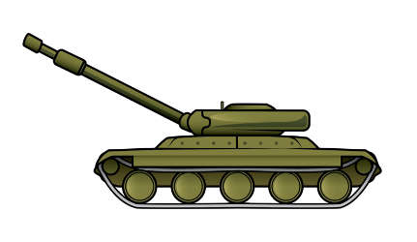

Hawks Class

Autumn 2018

World at War

**PE:** Dance and gymnastics.

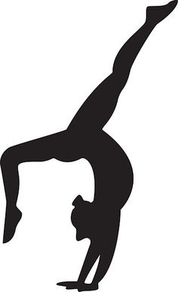

**FINAL EVENT**

Read and share our war diaries with Kingfisher class.

Perform our war poems to an audience.

**French:**

Learning basic French focussing on ‘Getting to Know You’.

**Computing**

Children are to research the blitz using a search engine.

This is to be alongside the teaching of safe internet use.

**PE:** Tri-golf and Tag Rugby

**Design and Technology Making ‘Rock Cakes’.**

**Science**

Looking at the properties and changes in materials.

**Art**

**Children will be creating a picture based on the blitz using sketching, layered paints and oil pastels.**

**English**

**Exploring a variety of war poems that focus on a range of themes. We will imitate, innovate and then finally invent our own war poem.**

**HOOK**Complete anair raid siren procedure in the classroom.

Evacuation – what would you pack? How would you feel?





**Music**

‘I’ll be There’

**English**

**Exploring ‘My Secret War Diary – By Flossie Albright’ and looking at how presentation, language and organisational devices structure a text and guide a reader. We are also going to be working on the use of brackets, dashes and commas for parenthesis and to mark boundaries between clauses. We will imitate, innovate and then invent our own war diary.**

.

.

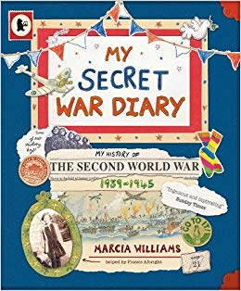



**Maths**

Place Value

Addition and Subtraction



**History**

Exploring World War two, focussing on a local history study in Slapton and Blackawton station. We will also look at evacuees, focussing on those who were sent to Devon.